

**Title: GNSS Lab Report**

Lab 1: GNSS Positioning

|  |  |
| --- | --- |
| Course: | AAE4203 — Guidance and Navigation |
| Group: | Group 2 |
| Members: | WANG Xuanting |
| Member IDs: | 23100379d |
| Instructor: | Prof. Weisong WEN |
| Department: | Department of Aeronautical and Aviation Engineering |
| School: | The Hong Kong Polytechnic University |
| Date: | 9, 11, 2025 |

# Abstract

This template demonstrates how to structure a PolyU lab report using the hkpolyu-labreport class. It includes examples of figures, tables, equations, code listings, and citations, while conforming to page and submission requirements.

**Keywords:** template, GNSS, SPP, least squares, figures, tables, citations, code

# 1 Data Collection

The process of data collection is divided into Hardware setup, Using u-center for Data Logging, Quick Product Configuration, and Experimental Task: Static Data Collection. The Hardware setup needs to first connect the Antenna with the u-blox GNSS receiver F9P kit and then connect them with computer. The Tool we need for collecting process is u-center. The environment we are in is a semi-open space surrounded by tall buildings, forming a complex "urban canyon" scene. GNSS signals are easily blocked or reflected, resulting in multipath effects. We choose X block to simulate this environment, like these pictures.

 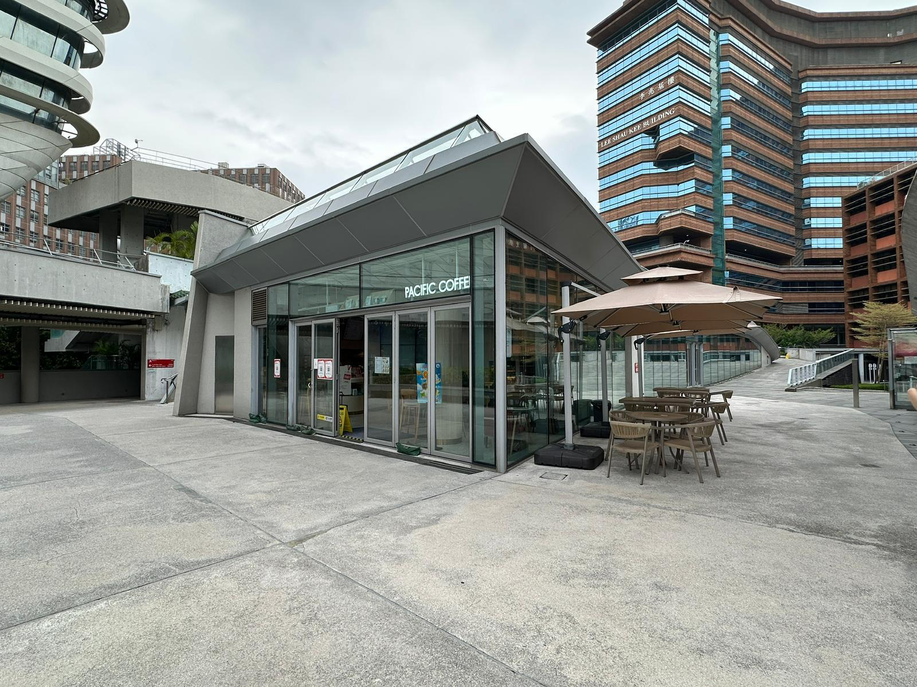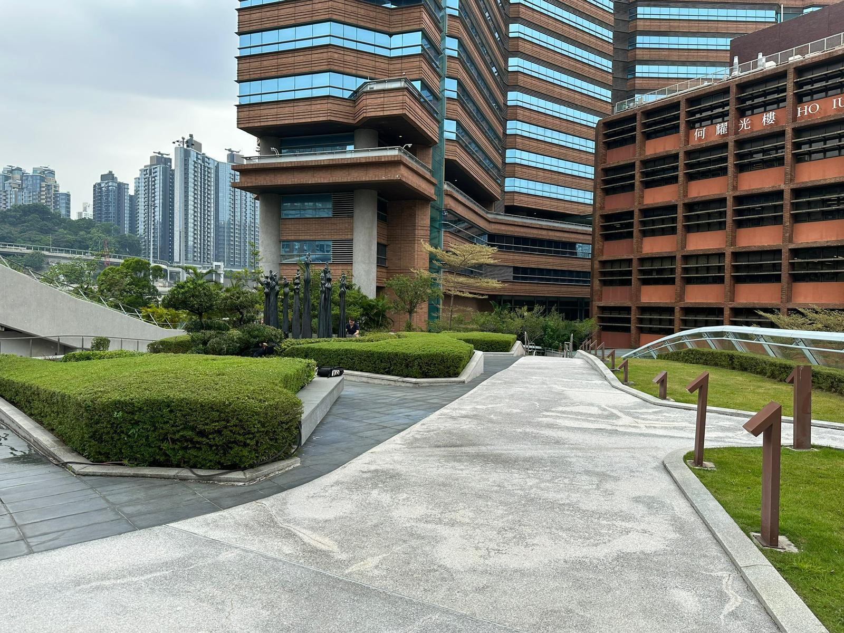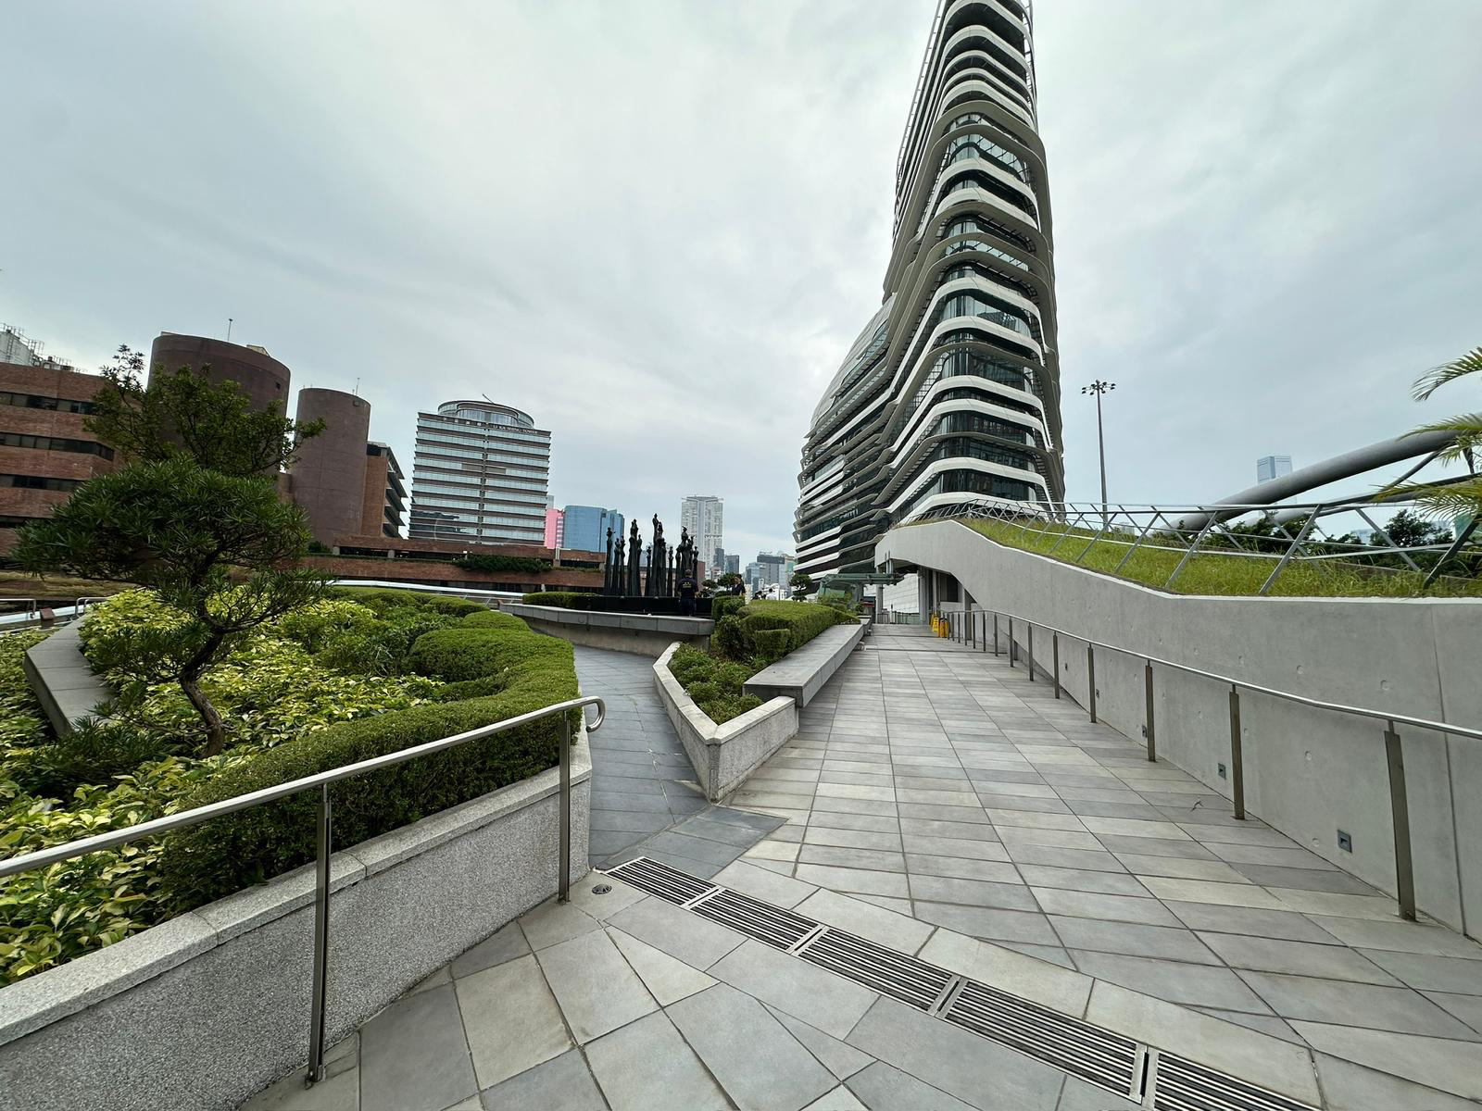

**Figure 1:** Data collection environment near Block X (placeholder).

Example table (log summary):

**Table 1:** Data collection summary (example format).

|  |  |
| --- | --- |
| Field | Value |
| Location | Vicinity of Block X |
| Duration | 30 min @ 1 Hz |
| Receiver | Multi-constellation GNSS |
| Conditions | Urban campus, partial obstruction |

# 2 Raw Data Analysis

After collecting we get a series of raw data, we need to convert it to RINEX which is the standard format for raw GNSS data. We first use SPP to obtain a preliminary trajectory; if you want to improve the positioning accuracy, you can introduce the high-precision star calendar and correction information provided by the local reference station. After a series of transformation operations, we can get plot results which includes ground track, position deviation over time, satellite visibility, and more.

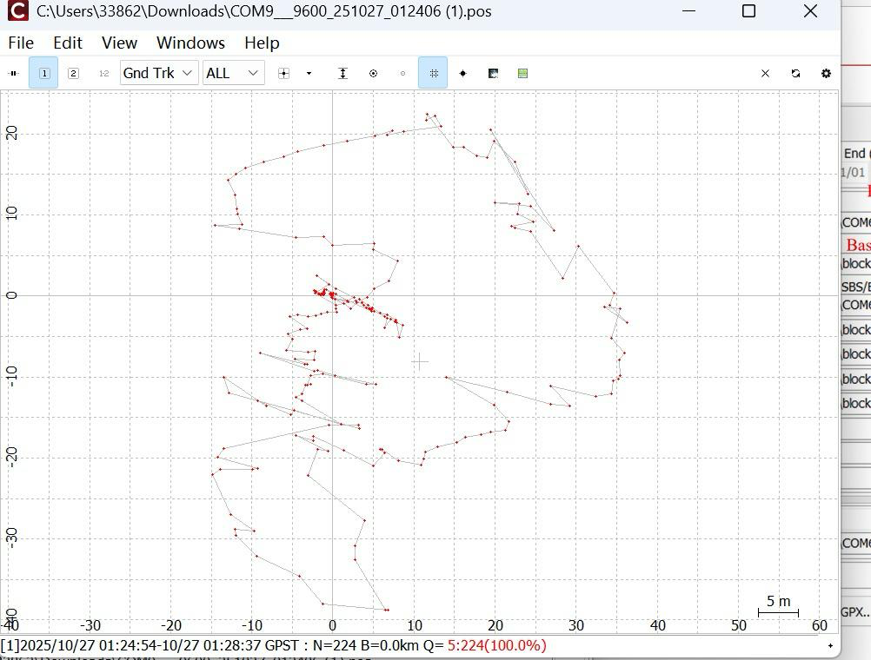

**Figure 2:** Illustration of the ground track.

Put data in Google Earth, we can get our calculated track overlaid on the map.

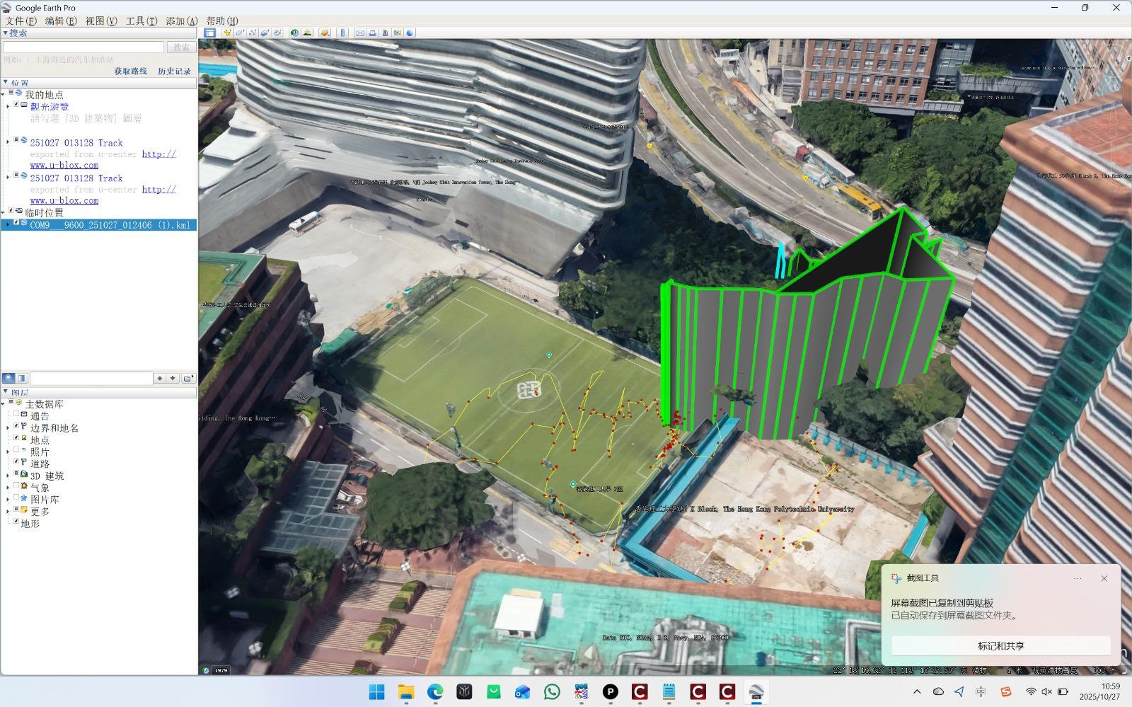

**Figure 3:**  **.**kml generated on Google Map

To get detailed data, we use signal-to-noise ratio (SNR) to analyze. Put the RINEX data in given Matlab script, we get following outputs.

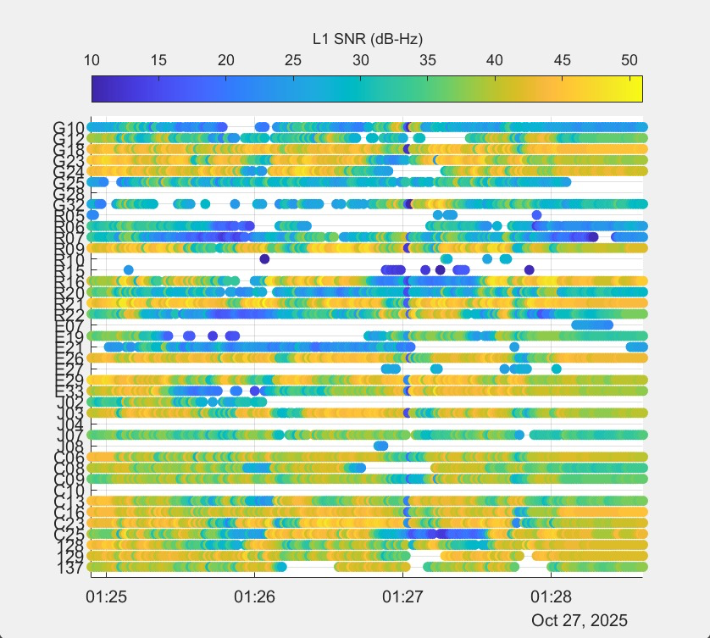 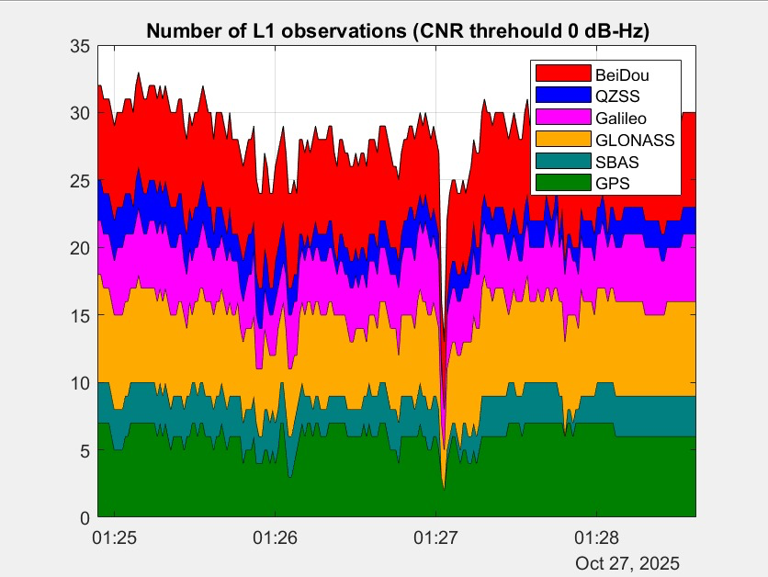

**Figure 4:** Received L1 SNR. **Figure 5:** L1 observation count over time

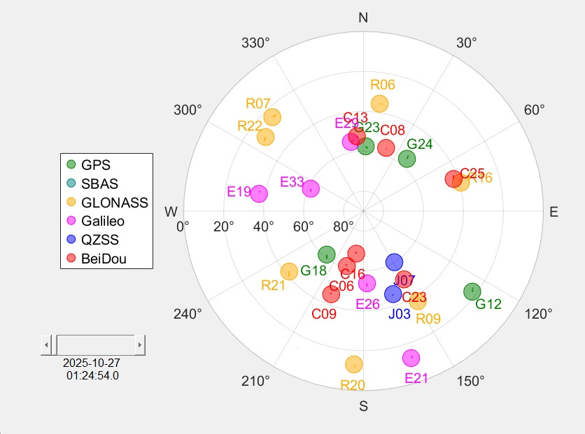 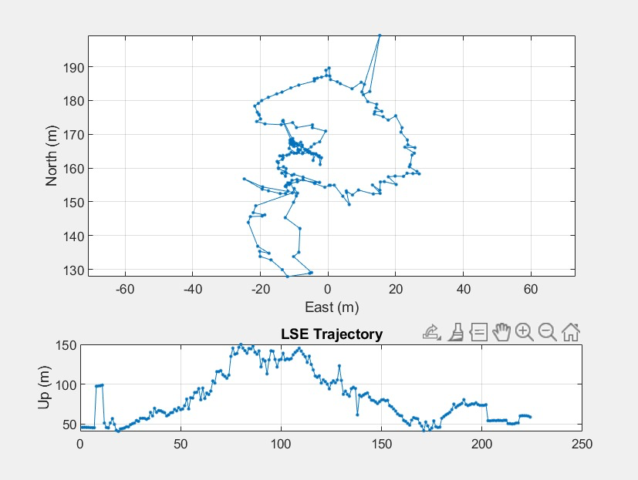

**Figure 6:** Satellite visibility and elevation angles. **Figure 7:** Single Point Positioning results

From figure 5, we can know that observed satellites per epoch mostly fluctuates between 22 and 32. Around 01:27, there was a steep drop, and the signal almost dropped to zero instantly, suspected of being blocked. The approximate proportion of the system composition is as follows: Beidou and Glonass are the main components, followed by Galileo. The noise ratio is mainly concentrated between 30 and 45 dB - Hz, which is within the normal range of semi-open to open outdoor environments. High SNR values of 45–50 dB‑Hz indicate excellent signal reception, while medium SNR values of 30–40 dB‑Hz represent good signal quality. So, the signal quality is totally good. Excellent signal reception Sporadic weak signals as low as 10-20 dB - Hz suggest the presence of occlusion, strong multipath or low-elevation observation. Around 01:27, the overall C/N0 suddenly dropped and was accompanied by a lack of measurement, corresponding to the collapse of the observed quantity in Figure 4. From the NAV-DOP.csv format, we get that Section 9,149,000–9,155,000: GDOP is about 1.43–1.57, low and stable. Section 9,155,000–9,164,000: gradually rise to the platform, about 1.73→2.39, then fall back and fluctuate between 1.6–2.1. The sky geometry of this section is lengthened, which may be due to: A number of high elevation satellites have fallen to the horizon/arith and gathered, and the proportion of low elevation has increased. There is occlusion in a certain direction (buildings, trees, car bodies), and the azimuth distribution is unbalanced. The system participates in the adjustment (such as using only GPS/less system in a short time), resulting in the deterioration of the number and distribution of visible stars. Segment after 9,164,000: GDOP dropped significantly to 1.42–1.50, then dropped to ≈1.30–1.34 and remained at ≈9,169,000–9,171,200 for a long time, and finally further reduced to 1.25–1 .30, which is the optimal for the whole segment, usually corresponds to the ideal geometry of "multi-system + multi-all + multi-height elevation angle". The overall GDOP of the main interval is 1.3–1.6, which is excellent, and the geometry is not the main source of error; although there is a platform that lasts for several minutes and several short-term peaks (up to about 2.39), it is still "acceptable/good", and there is no serious geometric degradation of >3. Lost lock/weekly jump mark: 01:27 There should be a global out-of-lock or a large number of weekly jump annotations near 01:27. Low C/N0 marking: Observations below the threshold (such as 25 dB-Hz) should be marked as "weak signal/not involved in the solution". Low elevation mask: When a 10–15° mask is set, some low elevation satellites on the south side should be marked and eliminated.

# 3 SPP Algorithm (Least Squares)

Single-point positioning (SPP) is an independent GNSS positioning method that uses pseudo-distance observation of multiple satellites to estimate the three-dimensional coordinates, clock deviation, and (optional) troposphere delay of the receiver. For the i-th satellite, its basic observation model is:

Ρ_i = ∥x − s_i∥ + cΔt + ε_i

Among them, ρ_i is the measured pseudo-distance, x is the receiver position vector, s_i is the satellite position vector, cΔt is the receiver clock deviation term, and ε_i gathers unmodeled errors (such as ionosphere, troposphere, multipath and measurement noise).

By linearizing the model at the a priori state x0, the normal equation of the standard least squares can be obtained. If the design matrix is H, the residual vector is v, and the weighted matrix is W (the unit matrix when not weighted, or the inverse of the observed variance modeled according to the elevation angle/C/N0), then the parameter increment δ is:

*𝛿* = ${(H^{T} W H)}^{-1}H^{T}$ W v

Weight W usually uses a model related to elevation or carrier-to-noise density ratio (C/N0) to reduce the impact of low elevation or low signal-to-noise ratio observations.

# 4 Code Listing

def solve_epoch(self, p_corr: np.ndarray, sat_pos: np.ndarray,

x0: Optional[np.ndarray] = None) -> Tuple:

"""

求解单历元

Returns:

(solution, H, nsat, success)

"""

# 筛选有效卫星

valid = np.isfinite(p_corr) & np.all(np.isfinite(sat_pos), axis=1)

idx = np.where(valid)[0]

if idx.size < 4:

return None, None, 0, False

P = p_corr[idx]

S = sat_pos[idx]

# 初始状态

xr = np.zeros(3) if x0 is None else np.array(x0[:3], dtype=float)

cb = 0.0 if (x0 is None or len(x0) < 4) else float(x0[3])

H_last = None

success = False

# 迭代求解

for iteration in range(self.max_iter):

# 向量化计算几何距离

diff = S - xr

rho = np.linalg.norm(diff, axis=1)

# 单位视线向量

u = (xr - S) / rho[:, np.newaxis]

# 残差

pred = rho + cb

v = P - pred

# 构建设计矩阵

H = np.column_stack([u, np.ones(len(idx))])

# LS更新

try:

dx = np.linalg.lstsq(H, v, rcond=None)[0]

except np.linalg.LinAlgError:

break

xr += dx[:3]

cb += dx[3]

H_last = H

if np.linalg.norm(dx) < self.tol:

success = True

break

if not success and H_last is not None:

success = True

return (xr[0], xr[1], xr[2], cb), H_last, idx.size, success

# 5 Results and Discussion

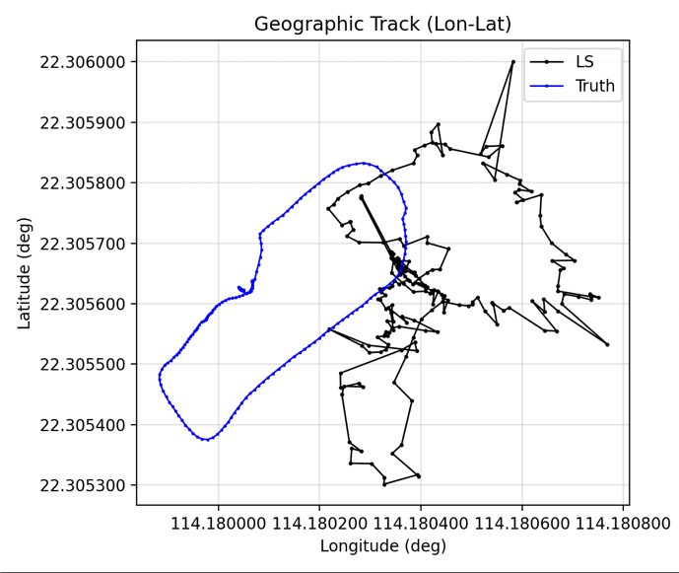 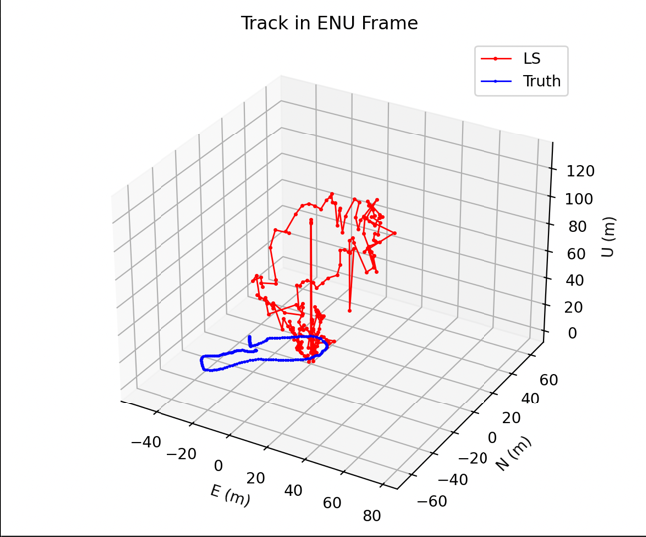

**Figure 8:** Geographic Track **Figure 9:** Track in ENU Frame

For figure 8, the bule line represents the true track, the black line means LS solution trajectory. The true value trajectory shows a smooth, continuous closed or almost closed elliptical curve, indicating that the actual movement of the target is relatively uniform and controlled, and may run along a fixed route. In contrast, the LS calculation trajectory shows obvious characteristics of divergent, jitter and jump, the connection between points is unstable, and there are multiple "peaks" and "foldback" phenomena. Although it is generally distributed near the true value trajectory (blue line), most of the position points are tens of meters away from the real path. In some periods, the LS trajectory is systematically biased to one side of the blue line, reflecting the existence of systematic deviation. It can be seen from the figure that the LS trajectory is mostly biased in the southeast direction (lower right), and the individual jump points deviate significantly, resulting in the distortion of the local trajectory. In general, the positioning error is mainly reflected in the offset of the longitude direction. Possible reasons include short-term interruption of satellite signals, multi-path or weak signal influence, and factors such as the failure of the least squares (LS) algorithm to filter, and insufficient anti-noise performance.

For figure 9, the blue line represents the real trajectory, that is, the actual movement path of. the target under the local ENU coordinate system; the red line represents the trajectory obtained through calculation. The blue line is an oval closed curve with a range of about tens of meters. It is located in the lower area of the coordinate system, indicating that the test object moves smoothly on the horizontal plane and the height is basically constant. In contrast, the deviation between the red line and the blue line is significant: the center of the overall trajectory is significantly higher than the real trajectory, the Up-direction changes drastically, and the maximum deviation exceeds 100 m; the distribution of points on the E and N planes is discrete, the fluctuation is random, and there is even a local self-crossing phenomenon. Although the overall shape is roughly similar to the real trajectory, it has been severely stretched and affected by noise. The main reasons for trajectory deviation may include: poor satellite geometry distribution and low altitude angle; altitude estimation is extremely sensitive to observational noise; and least squares (LS) algorithm does not consider constraints, such as fixed altitude plane or introducing inertial navigation auxiliary information.

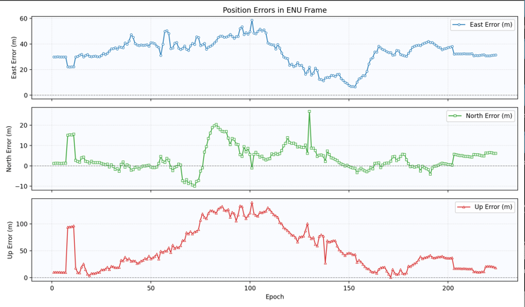 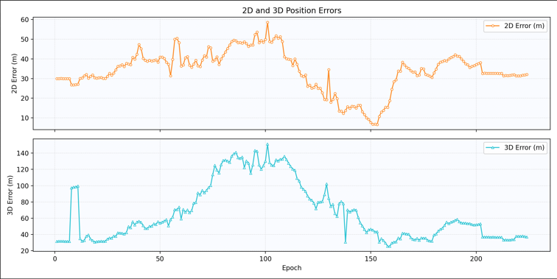

**Figure 10:** Position Errors in ENU Frame. **Figure 11:** 2D & 3D Position Error Over Time

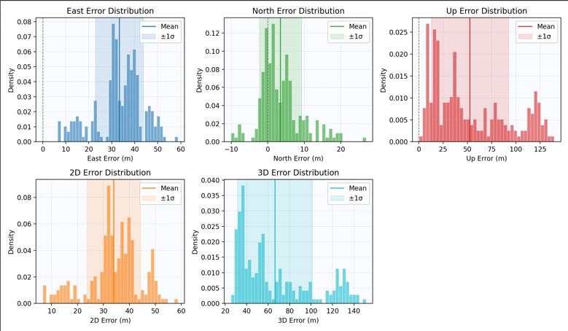 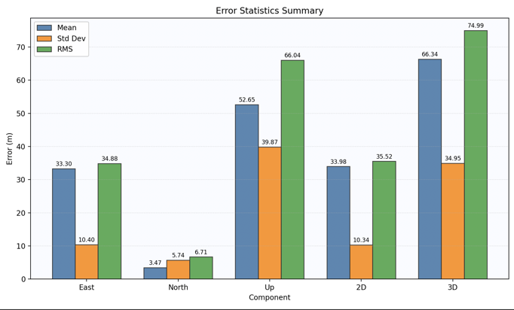

**Figure 12:** Histogram of Position Errors **figure 13:** Summary Statistics

For figure 10, the X-axis represents time or the number of observations, and the Y-axis represents the error value at the current moment t. for different direction (E/N/U), the error value is calculated by:

${ e}_{E}$ (t) = $E_{LS}$ (t) - $E_{Truth}$ (t)

${ e}_{N}$ (t) = $N_{LS}$ (t) - $N_{Truth}$ (t)

${ e}_{U}$ (t) = $U_{LS}$ (t) - $U_{Truth}$ (t)

Throng these three formulae, we can get the bule, green, and red lines. We can know that the eastward error fluctuates in the range of 30-60 m; the northbound error is around -10 to +15 m; the vertical error is 40-120 m.

For figure 11. With the calculation results in Figure 10, we can calculate the 2D and 3D error amplitudes for each epoch. The formulas used are as follows:

$$2D\left(t\right)= \sqrt{{e_{E}\left(t\right)}^{2}+{e_{N}(t)}^{2}}$$

$$3D\left(t\right)= \sqrt{{e_{E}\left(t\right)}^{2}+{e_{N}(t)}^{2}+{e_{U}(t)}^{2}}$$

Figure 11 shows the curves of 2D(t) and 3D(t) over time, and these two curves demonstrate the variation of the comprehensive error over time. So, from the image we can obtain: the planar error is mostly in the range of 30-50 m; The spatial error is approximately 40-130 m.

According to the figure 10 and figure 11, we get the value of $e_{E}\left(t\right)$, $e_{N}(t)$, ${ e}_{U}\left(t\right), 2D\left(t\right) and 3D(t)$ for all time. Then we combine them all in the graphs of figure 12.

Additionally, use the results all above, we can calculate mean value that represents the central position of the distribution, and standard deviation that means width.

Mean = $\frac{1}{N}\sum_{t=1}^{N}{e_{dir}}(t)$

Std = $\sqrt{\frac{1}{N-1}{\sum_{t=1}^{N}{(}e_{dir}\left(t\right)-Mean)}^{2}}$

So, we can get the following form.

**Table 2: Statistical Summary of Positioning Errors**

|  |  |  |  |
| --- | --- | --- | --- |
| component | Mean(m) | Std(m) | RMS(m) |
| East | 33.30 | 10.40 | 34.88 |
| North | 3.47 | 5.74 | 6.71 |
| Up | 52.65 | 39.87 | 66.04 |
| 2D | 33.98 | 10.34 | 35.52 |
| 3D | 66.34 | 34.95 | 74.99 |

In the urban canyon environment, the GNSS positioning system is inevitably interfered with by a variety of complex environmental factors. Due to the signal reflection and occlusion caused by high-rise buildings, the direction of incidence of the received signal often has errors, especially in areas with weak horizontal geometry (usually in the east-west direction), which will cause a systematic error in the eastward shift of the positioning results, and this deviation is relatively stable in time, and Eas in the observation The phenomenon of long-term positive bias of the t channel coincides. At the same time, the elevation angle of the visual satellite in the urban environment is limited, the visible area in the sky is narrow, and the satellite geometry is almost co-faceted in the vertical direction, resulting in a significant deterioration of vertical accuracy (VDOP), manifested as an average altitude error of more than 50 m, RMS of about 66 m, and altitude calculation drift and no Typical features of the bundle. In addition, as the moving target moves in the block, the satellites in the field of view are constantly changing, and each satellite group switching will cause discontinuous errors of several meters to tens of meters, which is reflected in the error fluctuations of East and Up channels. Finally, because the experiment adopts the least squares (LS) algorithm of independent calendar elements, which is only based on the pseudo-distance solution of single calendar elements and lacks time filter processing. Therefore, in the urban environment with high noise and poor geometric conditions, the error cannot be smoothed by time accumulation. If combined with auxiliary information such as Kalman filtering, inertial guidance (IMU) or map constraints, such drift can be significantly reduced and the positioning stability and accuracy in the urban environment can be improved.